“Nothing About Disabled People without Disabled People”.
Strategic Lead Co-production
Strategic Lead: this means the person that leads a piece of work, sets long term goals and plans the way to meet those goals.
Co-production: this means that Disabled residents and decision makers are working together in an active way to plan, design and review policy and services that affect our lives, to get rid of the barriers Disabled residents face.

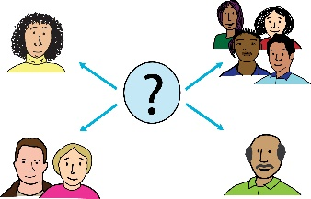
In Hammersmith & Fulham, we want to be the best council in the country by making decisions with our residents and not for them.
Residents: this means people living in an area.


We are proud of our achievements such as:
- Getting rid of home care charges

- Taking the lead in bringing child refugees into the UK
- Cutting council tax
- Not lowering the spending on keeping our communities safe
Home care charges: this is when people have to pay money towards their support/care.
Refugee: this is a person who has been told by the government that they can stay in the UK for as long as they need to. This is for their safety.

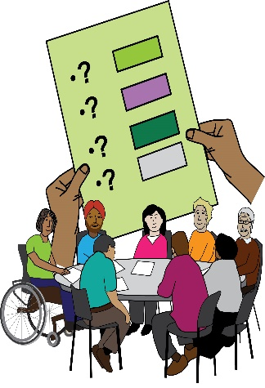
But we want to go further. After the work of our unique Disabled People’s Commission, made up of 10 Disabled residents, we are moving forward to put in place the recommendations of the report. https://www.lbhf.gov.uk/councillors-and-democracy/resident-led-commissions/disabled-people-s-commission
Unique: this means one of a kind.
Recommendations: these are the things that we think should happen to make things better.


We now aim to work to get rid of many of the barriers that Disabled residents who live and work in the Borough still face.
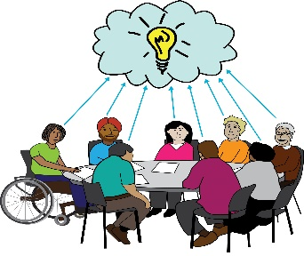
The person that gets this job will be a Disabled person. They will be the Councils strategic senior manager. They will work as part of our Public Services Reform Department.
Strategic senior manager: this is a manager at a high level who looks at big picture planning and how to carry it out.
Public Services Reform Department: this is a group of people or team that looks at changing public services to meet the needs of the people it works with.

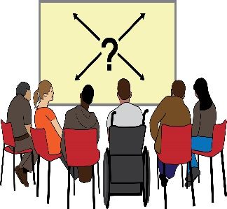
This person will be in charge of leading the work of the Hammersmith and Fulham Co-production Implementation Group. They will be in charge of strategic planning and making sure the work is going in the right direction.
Co-production Implementation Group: this is the group that is in charge of making sure co-production happens in the Borough. They are in charge of making sure that the changes needed are made, so that co-production can happen.
Strategic planning: this means big picture planning.

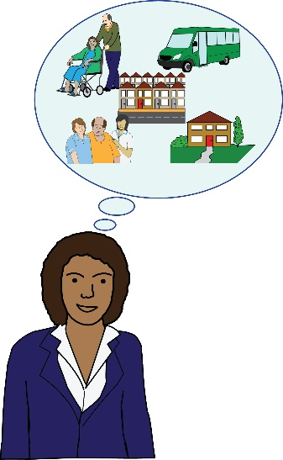
They will also be in charge of making sure that the planned work of the Hammersmith and Fulham Co-production Implementation Group is carried out all over the borough.
We are looking for Disabled people who share our vision and who want to work to turn that vision into reality.


You will have a strong background in influencing and bringing about change with Disabled people. You will bring a passion for public service and the hunger to change the way the Council works with Disabled residents. The need for public service change is key to our vision to be better in all that we do.
Salary: this means how much the person will get paid upto:
£65,505 per annum
What to do if you are interested in this role:

Please let us know if you want to apply for the role in a different way or in a different format.


Please send or email your application to:
Jacqueline Gordon,
Recruitment Co-ordinator
Corporate Serivces
Hammersmith and Fulham Council
1st Floor, Hammersmith Town Hall,

King Street, W6 9JU
jacqueline.gordon@lbhf.gov.uk

The closing date is
Friday, 28 December 2018 by 5pm.

